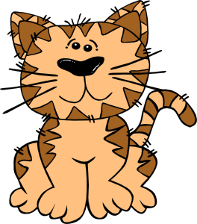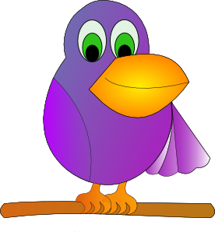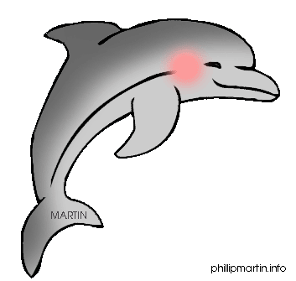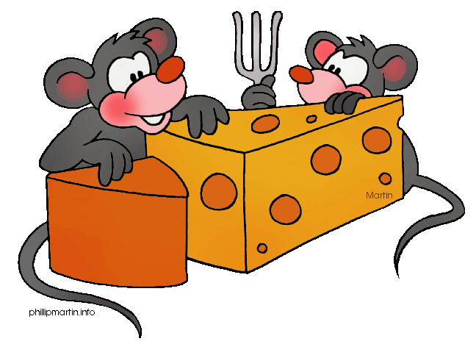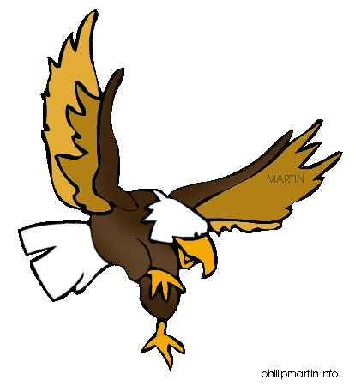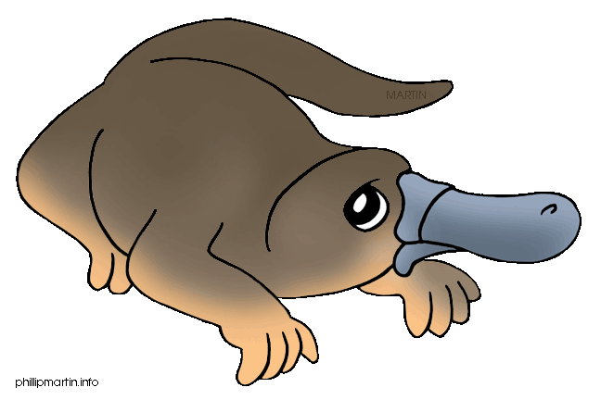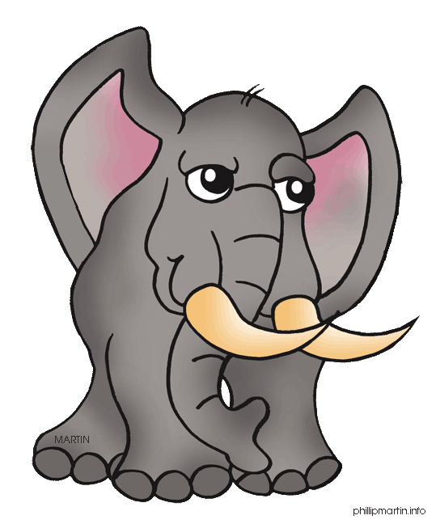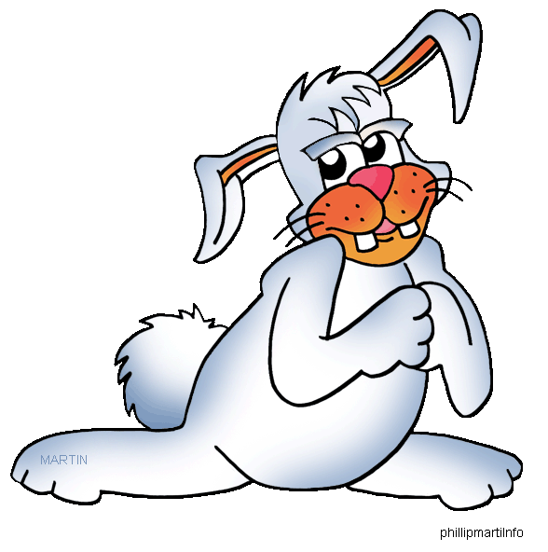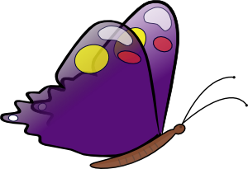

Jkkkkkkkkkjhh
(Starting Card)

It is a tropical bird that has the ability to mimic human speech.

Parrot

A “small” whale with a beaklike snout.
Dolphin

A small animal with a pointed snout, small rounded ears, and a long naked tail.
Mouse

A bird with a powerful hooked bill, keen vision, and long broad wings.
Eagle

A semiaquatic egg-laying animal with a broad flat tail, and webbed feet.

Platypus

A large grey animal with a long grey trunk. It has also got two tusks.
Elephant

A very soft animal with long ears. It loves carrots.
Rabbit

An insect with four colourful wings.
Butterfly

It looks like a dog but lives in the wild.
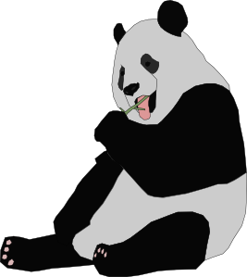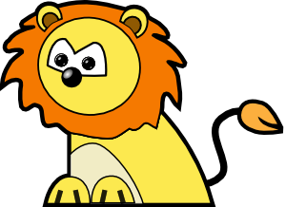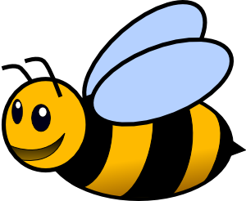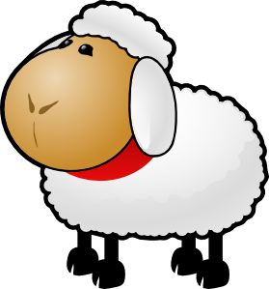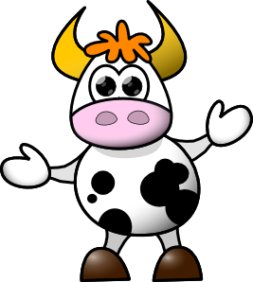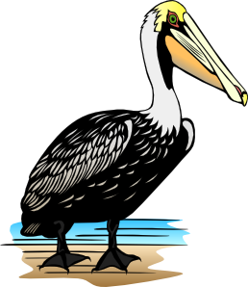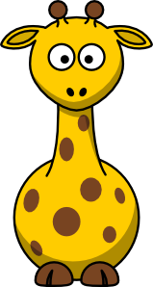
Wolf

A black and white bearlike mammal .
B
Panda

This animal is the king of all animals.
Lion

A small busy insect that produces honey.
Bee

This animal’s babies are called lambs.
Sheep

I eat grass and from me you get milk.
Cow

I have a hairless body, short legs, a large head. I live in and near rivers,

Hippopotamus

A fish-eating bird with a large bill.
Pelican

This animal has a very long neck. It lives in Africa on the savannah.
Giraffe

I live in Australia. I am very good at jumping.


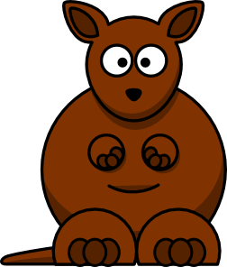
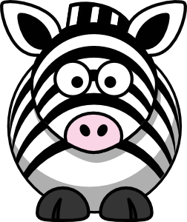
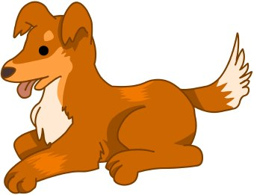
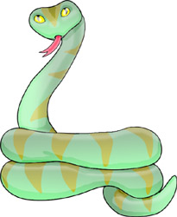
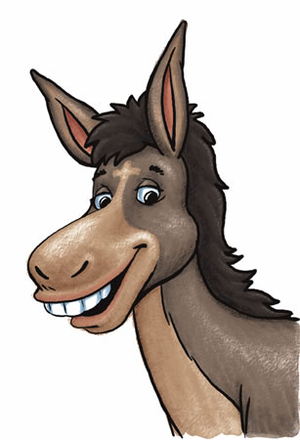
Kangaroo

I have black and white stripes. I am like a horse.
Donkey

A small animal that is a pet and that catches rats and mice.
Snake

I look like a horse but am not one. I am in the film “Shrek”.
Penguin

I have a
l o n g
body – no legs, no arms.
Dog

I am an aquatic bird of the Southern hemisphere. I have webbed feet and my wings are like flippers,
Zebra

People call me ”man’s best friend”.
What to do:
Cut out the cards and laminate for longer hold.

How to play:
Have groups of three to four students play the game.
Give each student eight or six cards.
The one to get the “Starting card” puts his card on the table. Reads the question aloud.
The student with the card that has the answer puts it down on the table (like in a Domino game) but the card is placed below the first card –
The student then reads the new question and the student with the correct answer places his card on the desk.
And so it goes ……..
PS: Notice that the Starting card has the answer of the question on the last card to be placed on the table.
1
2

